31st ANNUAL CONFERENCE

‘Risk Management for Task Based Exposures’

Wednesday, 29th and Thursday, 30th March 2023 The Strand Hotel, Limerick
OHSI Contact Information.
www.linkedin.com/in/occupational- hygiene-society-of-ireland-62855839 @OHIreland OHSI Website: www.ohireland.org
Email: ohsiireland@gmail.com

Workshop & Conference (March 29th and 30th 2023)
Workshop & Conference attendance | (OHSI Members) | (€245)
Workshop & Conference attendance | (Non Member) | (€305)
Conference attendance only | (OHSI Members) | (€245)
Conference attendance only | (Non Members) | (€305)
Retirees/Students conference attendance & lunch |  | (€60)
Conference Evening Dinner (Wednesday March 29th) |  | (€40)
Exhibition Stands – includes two people attending |  | (€450)
Fee includes refreshment, lunch and conference delegate pack.
If you wish to attend Conference Evening Dinner on Wednesday 29th March 2023 - €40.00, please specify in your online booking
(Please Note: there is an additional 2.5% booking fee for each of the charges above)
Please pay online using PayPal on our website http://www.ohireland.org/
Terms: Advanced payment required.
Contact Teresa on 086 8929613 or email at ohsiconference@yahoo.com for more information

Hotel Accommodation
Strand Hotel, Limerick City, V94 03F2
Phone: + 353 (0) 61 421 800 Email: info@strandlimerick.ie

Conference Sponsorship
OHSI would be very appreciative if you or your company wish to sponsor this conference. Please email us at ohsiireland@gmail.com for more information on sponsorship, thank you.

IOHA GLOBAL CONFERENCE IN DUBLIN IN 2024
OHSI and BOHS were successful in a joint bid to host the 2024 IOHA Global Conference in Dublin. We look forward to meeting you there in June 2024.
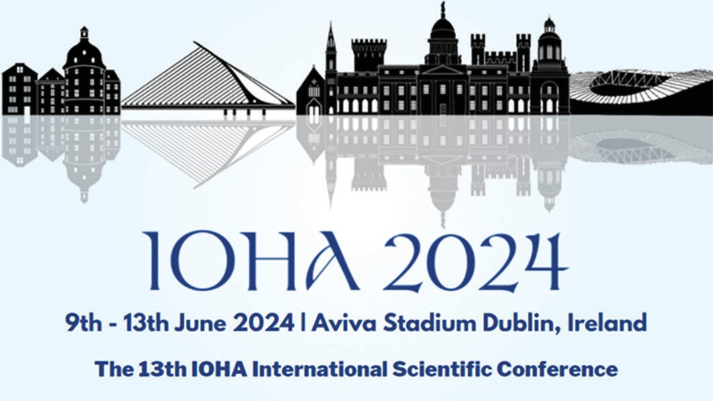

DAY 1- WORKSHOP

Wednesday 29 th March 2023 - 2pm - 5:30pm
“ NEW AND EMERGING TECHNOLOGIES IN OCCUPATIONAL HYGIENE”
“Presentations / equipment demonstrations from EMS, HSA, TNO, NIOSH, Dust Canary,
and GEA/Digital Canary”
2:00pm Coffee/Tea refreshments / start of workshop

3:30pm 4.00pm 5.30pm

Coffee/Tea Break Workshop continues Workshop Close

7:30pm OHSI AGM
8:00pm Conference Evening Dinner, Strand Hotel, Limerick.

DAY 2
Thursday, 30th March
‘RISK MANAGEMENT
FOR TASK BASED EXPOSURES’
08:15– 08:45 Registration, Tea, Coffee and Pastries.

08:50

09:00

09:10

09:50

10:30

Introduction to conference: OHSI Honorary President, Ms Shara Smith.

Update on the International Occupational Hygiene Association: Mr Maharshi Mehta: Honorary President, IOHA.

Annual Tom O’Connor Lecture: Asbestos, the HSA approach and new EU initiatives to better protect people from asbestos and ensure an asbestos- free future: Mr Darren Arkins, Health and Safety Authority.

Firefighter exposures: Mr. Stephan Koslitz, Institut der Ruhr-Universität- Bochum (IPA).
Firefighters are exposed to carcinogens such as polycyclic aromatic hydrocarbons (PAHs) during firefighting operations.

Meet the exhibitors

10:50

11:20

11:30

12:10

12:40

Coffee break

Collaborative project working with Irish Water, Local Authorities and chemical suppliers to improve overall chemical safety in the water industry with emphasis on bulk chemical offloads. Mr Keelan Harte, Final year B.Sc student in Environmental Health and Safety at the University of Galway.

Respirable crystalline silica, (RCS), controlling exposure: Ms. Chris Keen,
President BOHS, Principal Occupational Hygienist, HSE Science and Research Centre.

Promoting Occupational Hygiene Globally and Lessons Learned in Exposure Assessment. Mr Maharshi Mehta: President, IOHA.

Meet the exhibitors

13:00 – 14:15 Lunch and Exhibits

14:15 The growing legal and regulatory gulf between the UK and Ireland and the EU: Professor Kevin Bampton, CEO, BOHS

14:55 Oil Spill Investigation and Remediation – Ensuring worker protection, monitoring exposure to hydrocarbons and setting suitable guidance values: Dr. Gary Canny, Verde

15:35 Panel Discussion on topics presented during the day – Chairperson, Mr.
Michael Gillen, BioPharmaChem Ireland

16:45 Conference Close

SPEAKERS
Mr Maharshi Mehta: Maharshi is the elected Honorary President of IOHA and a distinguished Occupational Hygienist being the President of International Safety Systems Inc., which has offices in the USA, Ireland, Germany, the UK, France, India, Singapore, and China.
Mr. Darren Arkins: Darren is the manager of the Occupational Health and Hygiene Team within the Occupational Health Division of the Health and Safety Authority. Darren is also currently co-chair of the EU Commission’s SLIC CHEMEX Working Group which provide guidance and advice on EU Chemicals OSH legislation to Member State labour inspectorates.
Mr. Stephan Koslitz: Stephan is a chemist, has studied chemistry in Germany and Switzerland, and has worked since 2007 in the Institute for Prevention and Occupational Medicine, as part of the working group on Human Biomonitoring in the department of toxicology. He is expert in the analysis of dangerous substances at workplaces.
Ms. Chris Keen: Chris is the President of the British Occupational Hygiene Society, BOHS and the technical lead for occupational hygiene at the Health and Safety Executive’s Science and Research Centre in Buxton. She has co-authored several papers which have been published in the Annals of Work Exposures and Health.
Mr. Keelan Harte: Keelan is a final year B.Sc student in University of Galway. He completed his work placement in Irish Water where he gained valuable experience in risk management in the water industry.
Professor Kevin Bampton: Kevin was professor of law at Derby University and subsequently professor of public law at De Montfort University. In 2020 he moved from academia to become the Chief Executive of BOHS.
Dr. Gary Canny: Gary is the Technical Manager with Verde Environmental Consultants and has over 25 years’ experience in the environmental consultancy field, having dealt with over 5,000 spill incidents. He has developed specialist knowledge in oil spill response, contamination investigation and remediation.
Dr. Michael Gillen: Michael is a Senior Executive with BioParmaChem Ireland (BPCI), where he has responsibility for environment, and health and safety. He is also the head of occupational health & safety (OHS) policy in the Irish Employers and Business Confederation Ibec. He is Chairperson of the Management & Executive Boards of the European Agency for Safety and Health at Work (EU-OSHA) and is an employer representative on the European Commissions’ Advisory Committee on Safety & Health (ACSH). He is a former Deputy Chairperson of the Board of the HSA.

